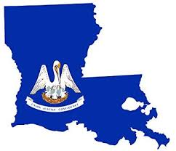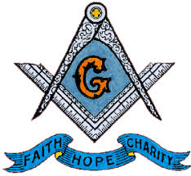**KADOSH LODGE #148**

# **LOUISIANA JURISDICTION**

**OVERSEAS DISTRICT**

Date: December 12, 2024

FROM: Worshipful Master Gray Freeland

I challenge each Member to conduct service at your locate schools or community, by representing yourself as a Master Mason of Kadosh Lodge # 148. Your challenge is to support and reach our youth. Let’s mentor our young men to become upright men.

Conduct a Zoom Lodge meeting at 10 am CST

**Main**

January TBD EXECUTIVE COUNCIL/INSTALLATION/

**BUSINESS MEETING**

January 11th Business Meeting

March 24th Pelican Council of Deliberation (Scottish Rite)

April 12th Business Meeting

June TBD St. John the Baptist District Celebration / GRAND SESSION / ST. JOHNS DAY CELEBRATION

July 12th Business Meeting

September TBD Prince Hall and Americanism Day Celebration

October 11th Business Meeting

December 06 Election of Officers

Continue Support of Lecture Department (Grand and District) by participating in Webinars or whatever is needed from our lodge members.

Support the St. John the Baptist District Celebration as Kadosh Lodge 148 will be hosting the event.

Continue to Support the Homeless Shelter Project in Alabama, PM Kenneth Joshua’s Program.

Christmas in July for Brothers to pay yearly dues early.

Very Respectfully,

Gary Freeland

Worshipful Master

Kadosh Lodge #148